Castillo de San Marcos National Monument
Student Worksheet- Fourth Grade Live Distance Learning Program

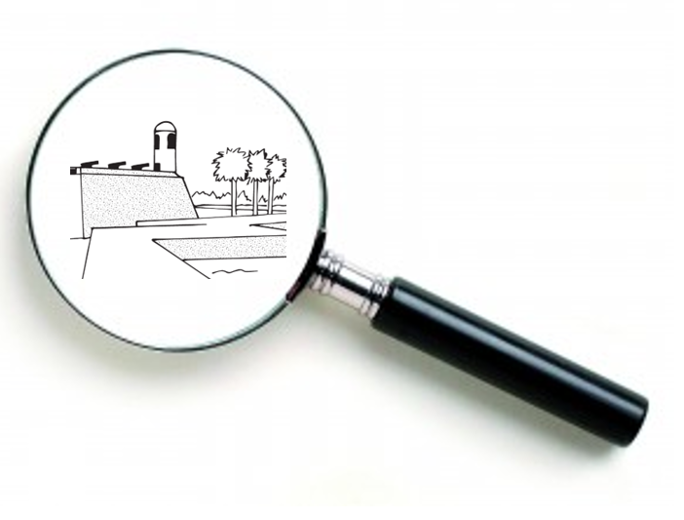
Think like an Archeologist!
As an Archaeologist, you must have practical skills! Observe, explore, investigate, examine! Record your findings!

Archeologists must represent their knowledge and findings. Draw a picture or diagram here of something you observed!

\

Part of an Archeologist’s job involves studying and analyzing. What can you infer, theorize, suggest based on your observations?

Part of an Archeologist’s job involves developing more questions. What questions do you want answered?

WORD BANK: Castillo de San Marcos, St. Augustine, Timucua, artifact, secondary source, Fort Mose, primary source
Can you match the words above with their definitions?
An object made by a human being (examples: structures, tools, pottery, weapons, jewelry, metal objects).
An original object, artifact, or first-hand account from people who had a direct connection with it (examples: artifact, diary, photograph, autobiography, video, newspaper).
Gives information about a primary source (examples: textbook, biography, documentary, article, or website written about the topic).
Native American people who lived in Florida for over 12,000 years before the arrival of the Europeans. Many died of diseases brought by the Europeans, some fought back or ran away, some married Spanish soldiers, and some helped built the fort.
The oldest stone fort in the continental U.S. It was built from coquina, shaped like a star, built by many diverse people (Native Americans, Spanish, Africans, etc.), and owned/used by many nations (Spain, Britain, U.S.).
The first free African American settlement in what is now the U.S.
The oldest permanently occupied European settlement in the U.S.
There were many causes and effects of Spanish rule in Florida. Try to identify the 1-8 as a cause (reason) or an effect (result). You can draw lines to the words or write them in each box.
1. The Spanish wanted to spread Christianity. | CAUSE?  OR  EFFECT? | 5. Spain wanted an empire, a lot of areas under their control.
2. Spain wanted to protect their treasure route. |  | 6. Europeans wanted land, trade, new resources, and new opportunities.
3. Many Native Americans died from diseases spread by the Europeans. |  | 7. The Spanish built Castillo de San Marcos to protect St. Augustine and their treasure route.
4. St. Augustine became a very diverse society made up of people from different nations, races, languages, and cultures. |  | 8. The Spanish built many towns, Catholic missions, and forts, like Fort Mose, in Florida.

Enrichment activity for discussion or writing exercise: Choose one of the following questions to answer. Be sure to justify (explain) your answer.
  - What does the fort represent/symbolize?

  - What can we learn from the fort and the people who came before us?

  - How important are primary sources, like Castillo de San Marcos, when it comes to learning about the past?

  - Why do you think the fort should be preserved?

  - As a citizen, what are your duties or responsibilities at the Castillo or in other national parks?

Castillo de San Marcos National Monument
Answer Key- Fourth Grade Live Distance Learning Program for screen reader accessibility.

Think like an Archeologist!
- As an Archaeologist, you must listen and learn from others. As the ranger describes Castillo de San Marcos, record the words that stand out to you.

- Archeologists must represent their knowledge and findings. The fort’s shape is important. Is Castillo shaped like a square, triangle, star, or circle? Draw that shape that best represents Castillo de San Marcos.

- Part of an Archeologist’s job involves studying and analyzing. What can you infer, theorize, suggest about the people who built this fort?

- Part of an Archeologist’s job involves developing more questions. What questions do you want answered?

WORD BANK: Castillo de San Marcos, St. Augustine, Timucua, artifact, secondary source, Fort Mose, primary source
Can you match the words above with their definitions?
An object made by a human being (examples: structures, tools, pottery, weapons, jewelry, metal objects).
An original object, artifact, or first-hand account from people who had a direct connection with it (examples: artifact, diary, photograph, autobiography, video, newspaper).
Gives information about a primary source (examples: textbook, biography, documentary, article, or website written about the topic).
Native American people who lived in Florida for over 12,000 years before the arrival of the Europeans. Many died of diseases brought by the Europeans, some fought back or ran away, some married Spanish soldiers, and some helped built the fort.
The oldest stone fort in the continental U.S. It was built from coquina, shaped like a star, built by many diverse people (Native Americans, Spanish, Africans, etc.), and owned/used by many nations (Spain, Britain, U.S.).
The first free African American settlement in what is now the U.S.
The oldest permanently occupied European settlement in the U.S.

There were many causes and effects of Spanish rule in Florida. | Try to identify the 1-8 as a cause (reason) or an effect (result).
1. The Spanish wanted to spread Christianity.
2. Spain wanted to protect their treasure route.
3. Many Native Americans died from diseases spread by the Europeans.
4. St. Augustine became a very diverse society made up of people from different nations, races, languages, and cultures.
5. Spain wanted an empire, a lot of areas under their control.
6. Europeans wanted land, trade, new resources, and new opportunities.
7. The Spanish built Castillo de San Marcos to protect St. Augustine and their treasure route.
8. The Spanish built many towns, Catholic missions, and forts, like Fort Mose, in Florida.

Enrichment activity for discussion or writing exercise: Choose one of the following questions to answer. Be sure to justify (explain) your answer.
  - What does the fort represent/symbolize?

  - What can we learn from the fort and the people who came before us?

  - How important are primary sources, like Castillo de San Marcos, when it comes to learning about the past?

  - Why do you think the fort should be preserved?

  - As a citizen, what are your duties or responsibilities at the Castillo or in other national parks?

